Creating a Career INFOGRAPHIC
What is an Infographic?

An infographic is a visual story about a specific item. You will create an infographic on your top career choice from the Career Cruising web site.

Strategy:
- What is the purpose? To tell others all about a specific career.
- Who is the audience? All high school students researching different careers.
- What are you trying to communicate? Details about a career in a visual format.
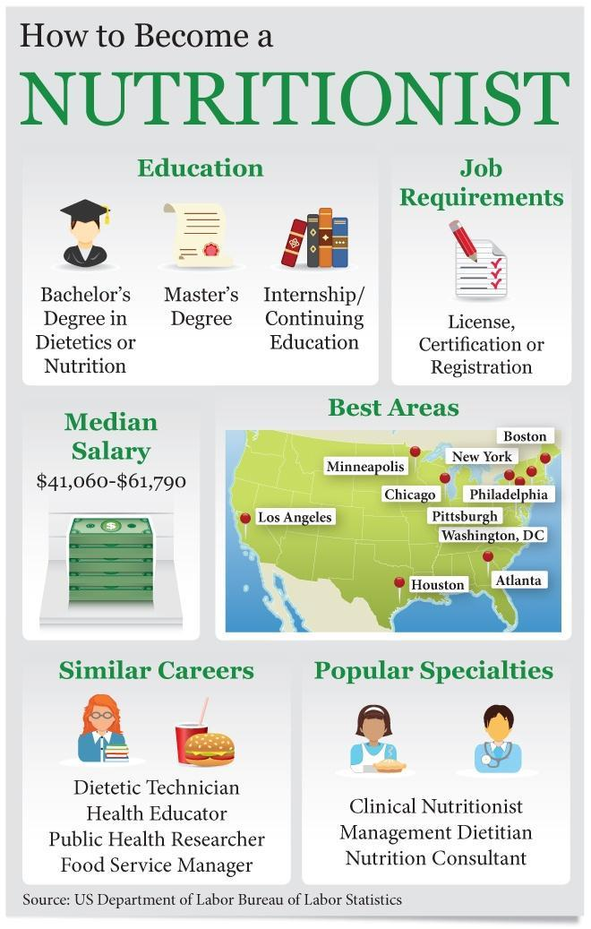
- What resources should I use? Career Cruising. If you want more information about your career, go to http://www.bls.gov/k12/content/students/careers/career-exploration.htm

Items to Include:

- Name of your top/first career choice
- Brief description of the occupation
- Working conditions and or tasks
- Michigan Annual Median Earnings
- Michigan Average Annual Openings
- Type of education, training or preparation
- Related Careers
- Other Resources
- Must have your name and source at the bottom of the document

You may add any additional information as you wish based on your career.

See examples of different infographics here

Directions:
- Open piktochart.com
- Watch this video

